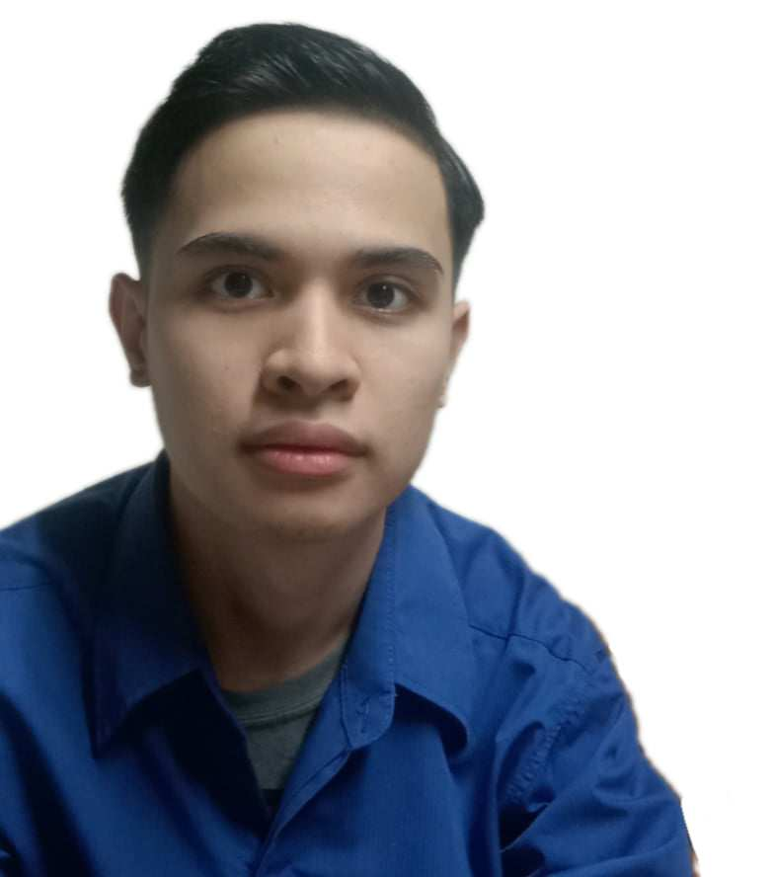**Regie Marzan**

Quezon City, Metro Manila | 09569144869 | lonebeginner@gmail.com

**Profile**

A Web Developer familiar with HTML/CSS, Javascript included PHP, able too creative designs and still learning and self-developing about coding.

**Relevant Links**

Linkedin: [Regie Marzan](https://www.linkedin.com/in/regie-m-067755282/)

GIthub: [Regie Marzan](https://github.com/regiem14?tab=repositories)

Portfolio: [Regie Marzan](https://regiem14.github.io/Regie-Portfolio/)

**Project Experience**

KodeGo – Full Stack Web Development Bootcamp

Capstone 1

* Tools used: HTML, CSS
* I presentation my portfolio
* I make my own website using all my previous designs that I learned it.

**Key Skills**

Front-End: HTML, CSS,

**Education**

KodeGo - Full Stack Web Development Bootcamp

ABE International Business College - BS Information Technology - 2nd year College

Feb. 2023 - June 2023

March 2021 – Dec. 2022